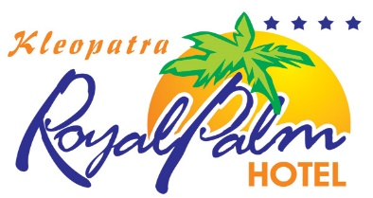 

**KLEOPATRA ROYAL PALM HOTEL**

**ALL INCLUSIVE CONCEPT**

**Breakfast with buffet 08:00 - 10:00**

**Lunch 12:30 - 14:00**

**Snack 14:30 - 16:00**

**Coffee and cake 16:00 - 17:00**

**Dinner 19:00 - 21:00 (The time can be changed in the season)**

**Pool bar; all local drinks 10:00 - 23:00**

**Free of Charge Services (Included on All Inc.)**

TV (Sat)

Table Tennis

Fitness room

Pool sun bed and umbrella

**Services with an Extra Charge**

FOR Wi-Fi

USER NAME= ROOM NUMBER

PASSWORD = DATE OF BİRTH

All import drinks (including Miller and Beck’s beer)

Refrigerator

Telephone and Fax

**SAFE BOX in the room per day 2 €**

Sauna

Massage

Peeling

Doctor

All kind of Ice-cream, waffles, all cakes outside the buffet

All fresh juices

Billiard

Internet corner

The drinks,Meal,Sun bed and umbrella on the beach

A la carte lunch & dinner which are served at the snack bar or beach

Espresso, cappuccino and Turkish coffee

***\*\*SUGGESTION & ATTENTION\*\****

*- The BEACH (Sun beds and umbrella) will be 10% cheaper if you buy it WEEKLY from the Reception.*

*- It is strictly NOT allowed to take foods and drinks to the hotel rooms from lobby bar and open buffet.*

*- It is forbidden to use hotel towels at the pool, beach and Turkish Bath. Hotel towels should be leaved in the rooms.*

*- Please pay attention to this information:* ***We change your towels every 2nd and your sheets every 3rd day.***

***CHECK IN : 14:00 PM - - - - - CHECK OUT : 12:00 PM***

***POOL OPPENING TIME 08:00 PM CLOSEING : 17:00 PM***

*We wish you to have a pleasant holiday in our hotel…*