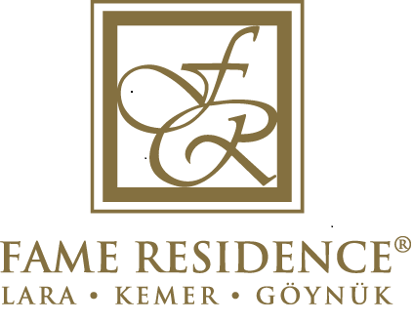

FAME RESIDENCE KEMER & SPA

LOCATION : Our 5 stars Hotel with ISO 9001: 2008 certificates, Blue Flag, Green Key and Green Star Awards is in Kemer where all colours of nature are combined in a fantastic harmony.

DISTANCE KM

Antalya Airport 50 km

Antalya City Center 40 km
Beach 0 m
Kemer Bus Station 1 km

ROOMS ALLOCATION & NUMBER OF ROOMS:
All rooms are with sea, garden or mountain view. 24 Family, 2 Handicapped Rooms and Standard Rooms; Total 246 Rooms , 508 Beds.

DESIGN:
Modern and deluxe interior decoration, laminate floor, balcony or french balcony, bathroom with shower, WC, direct dial phone, hairdryer, minibar, kettle, tea & coffee service, safe box, satellite TV, music channel, AC 220V, central air condition & heating,

RESTAURANTS & BARS:

Main Restaurant, A’ La Carte Restaurant, Lobby Bar, Pub Bar, Beach Snack Bar, Pool Bar, Disco Bar, Arcade Bar, Café Fame, Room Service.

BEACH / POOL:
Beach: On the private beach of the hotel which disposes of a BLUE FLAG, sun chairs, mattresses, sun umbrellas and beach/pool towels are at Your service.

Pools:
1 Outdoor Swimming Pool | 270 m²
1 Indoor Swimming Pool | 195 m²
1 Outdoor Children Pool | 20m²

ENTERTAINMENT:
As in Soft Animation concept, daily sport activities and shows organized by the animation team will take You to a fantastic world. Moreover, the examples of hits of the world music market performed at the Discotheque will give You the real rhythm of life. The Mini Club for children between 04-12 will be also at Your service.

OTHER ACTIVITIES:
- Laundry Service
- Baby Sitting (upon request)
- Doctor & Nurse
- Photo Shop
- Leather Shop
- Boutique
- Market
- Optic Shop
- Hairdresser for women and men
- Shoe Polishing
- Parking Lot
- Turkish Bath
- Sauna
- Fame Residence Beauty Center
- Jacuzzi
- Fitness Center
- Billiard
- Bowling
- Game Center (Table Football, Air Hockey, Arcade Games etc.)
- Wireless Internet Connection

  - Accepted Credit Cards: Visa, Master, Eurocard

SPA & WELLNESS CENTER:
Indoor Pool, Turkish Bath, Finnish Bath, Sauna, Jacuzzi, Massage, Turkish Style Peeling (Kese), Full Body Care, Different kind of Masks (Algimud, Mud etc.), Massages with Aromatherapy, Dermalife SPA Jet, Cellulite Firming Gel.
MEETING HALL:
«HALL I», «HALL II» and «HALL III» - Meeting Halls I, II and III have the capacity of 30, 40 and 50 pax. All Meeting Halls divided by the folding partition wall have the total capacity of 120 pax.

